**Theory Assignment#2**

**Subject: Visual Programming**

**Submission Date:26/3/2024**

|  |  |
| --- | --- |
| CLO2 |  |

**Question#1: Pass Data from Form1 to Form2 using following methods:**

1. **Using constructor**
2. **Using objects**
3. **Using properties**

**Example strand is given below:**

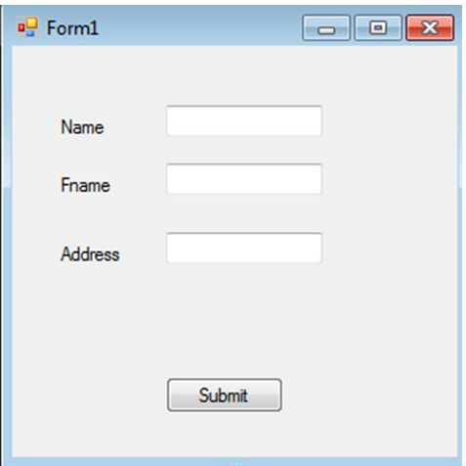

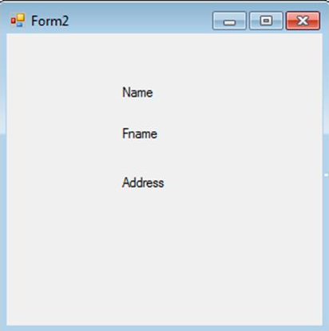

Note: Copy your code in word file, file should be saved by your registration number. Your assignment should have your registration number, name, assignment number, section and date. Submit assignment to your CR till 4:30 pm on 26th march 2024.